# Introduction

As it was required, the website provides opportunity for the following actions:

* Create an account
* Login
* Buy a ticket
* Add credit (top-up balance)
* Reserve camping spot
* Leave a review
* Logout
* Contact Us

It is also possible to get information from the website pages: about event, reviews. For the logged in user it’s also possible to see information about balance/ticket number.

You can test the website. It is located on <http://i415306.hera.fhict.nl/Home.php>

# Create an account

Creating the account is possible in two ways. First one is to click “Buy a ticket” button on the Home page. 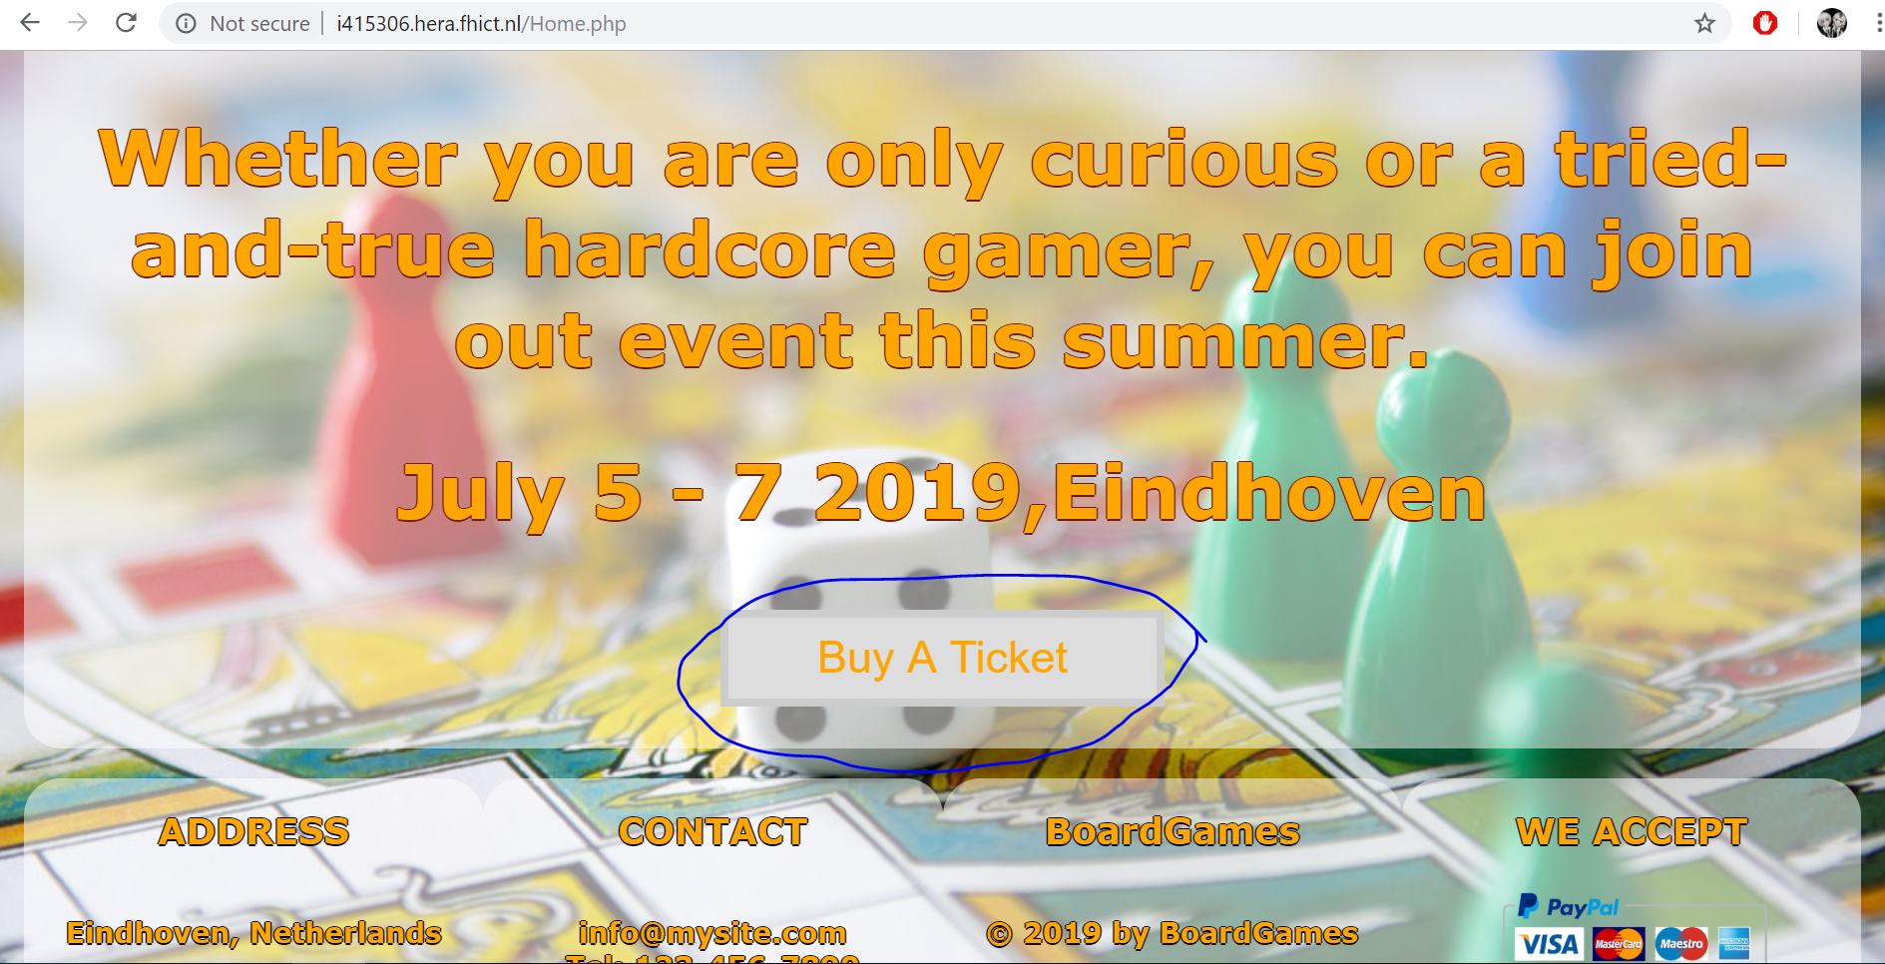

Second one is to click “Log in”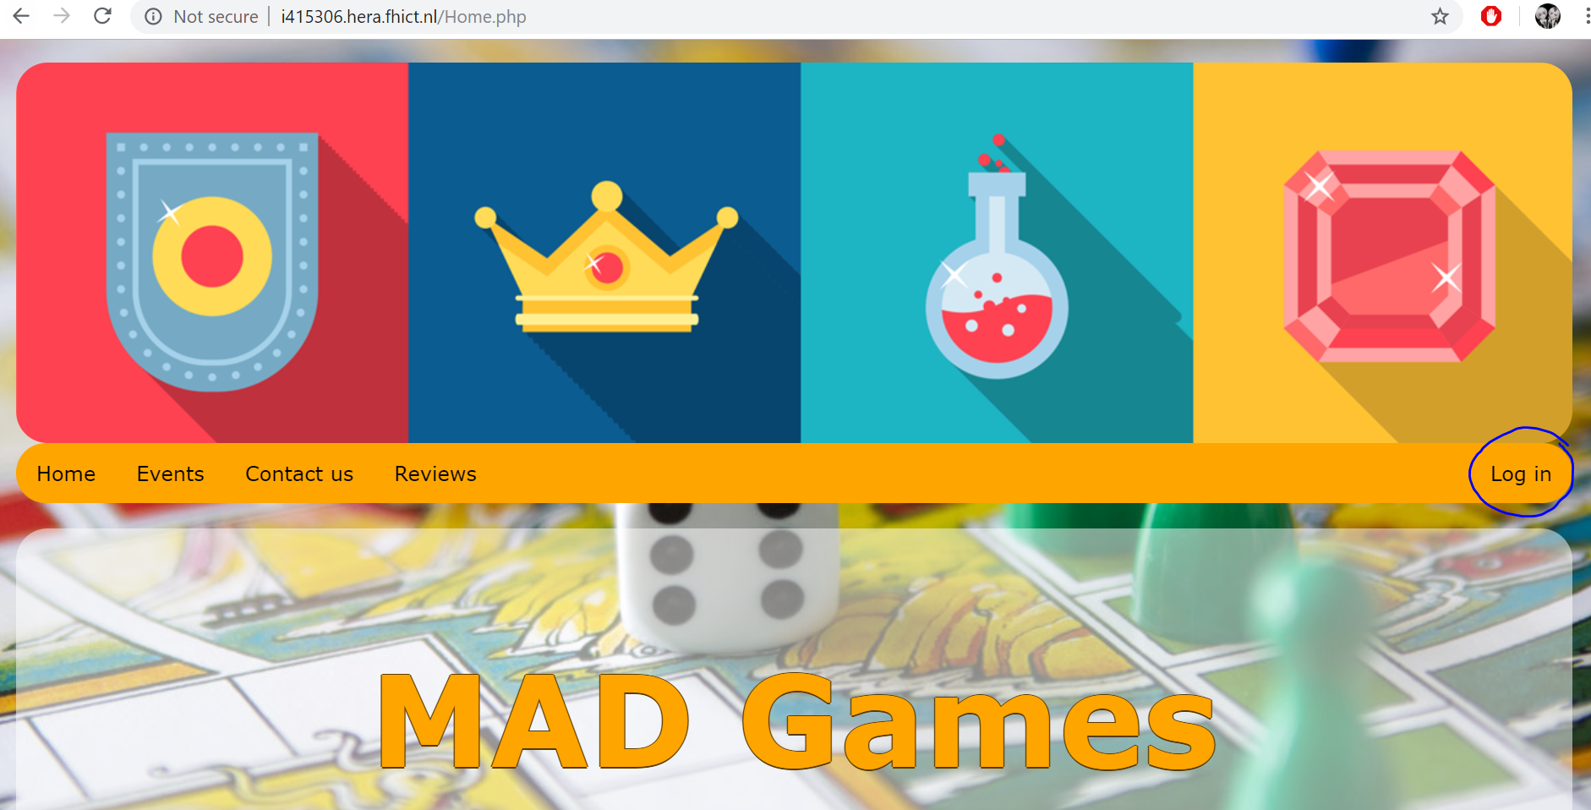

And click “Register” under the log in form.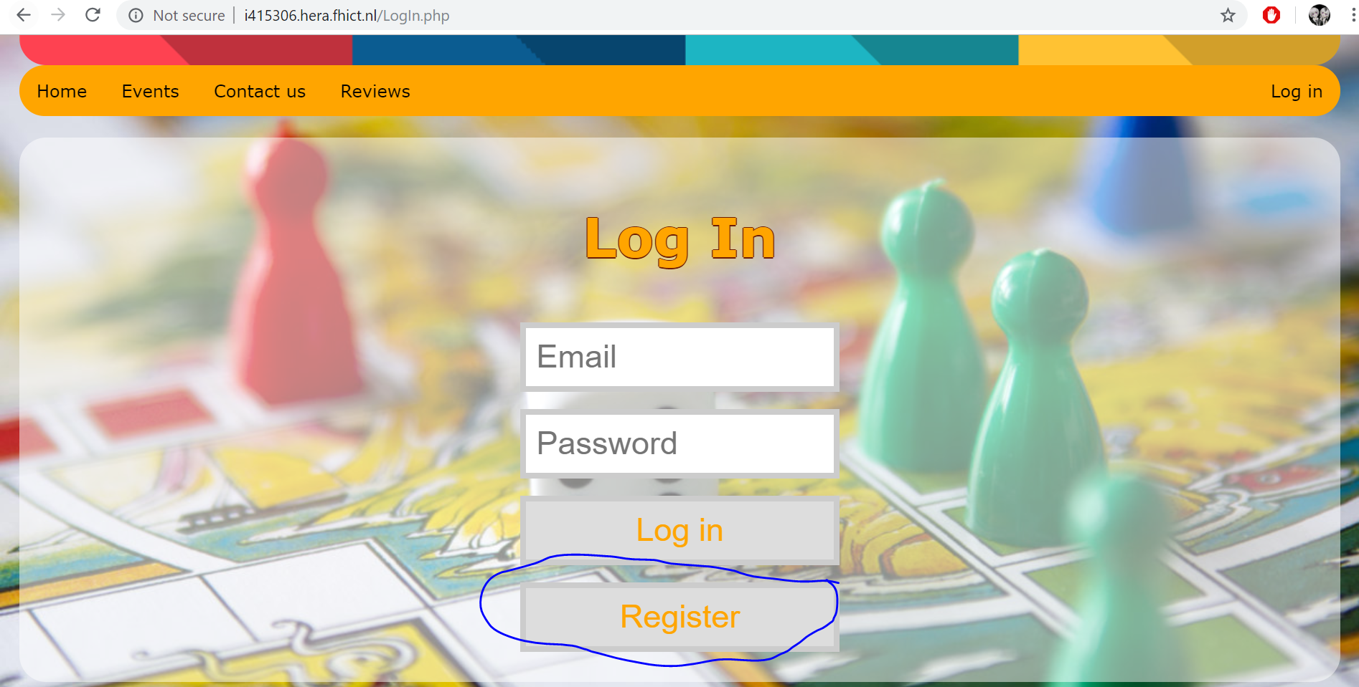

These two ways will lead you to the same registration page that is shown below. On this page you need to provide all the data and press “Register” button. You can’t register an account with already registered email.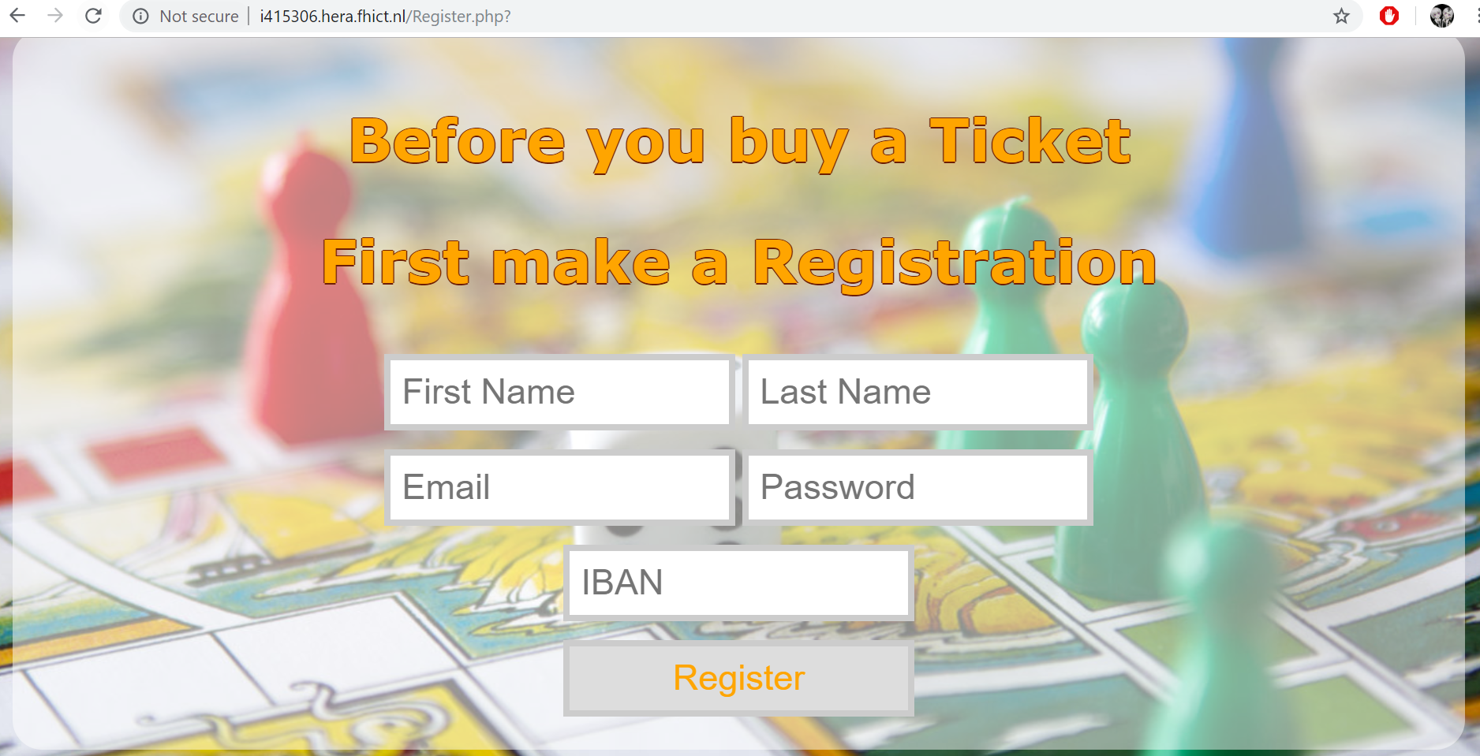

After providing the data and pressing register, you will be redirected to “Log In” page where you can log in with the details you submitted.

# Log in

For log in you need to press “Log in” in menu bar. This will redirect you to Login page.  
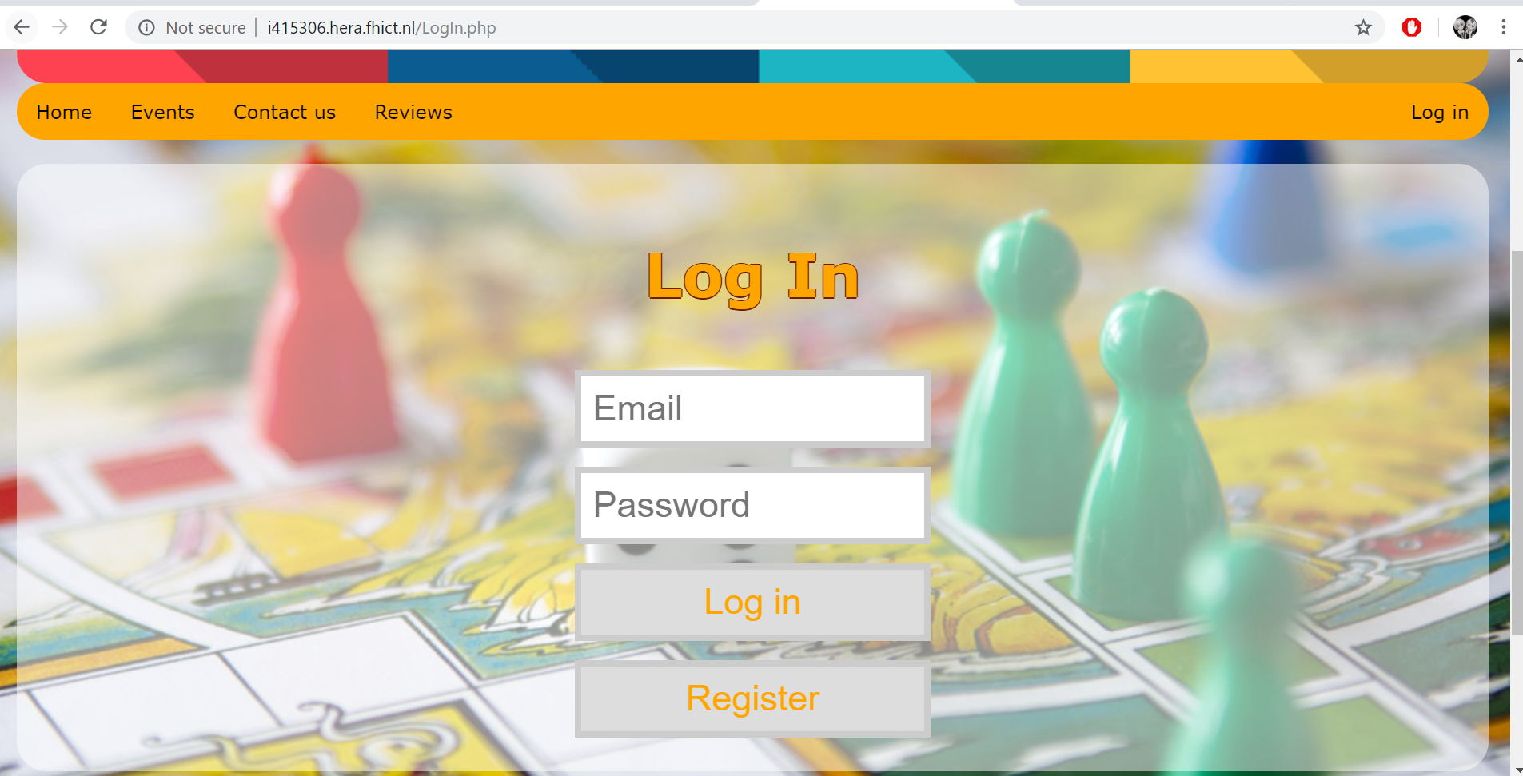

Provide your login data and you will be redirected to your profile page. Your menu bar will have Profile and Log Out option instead of Log in while you’re logged in.  
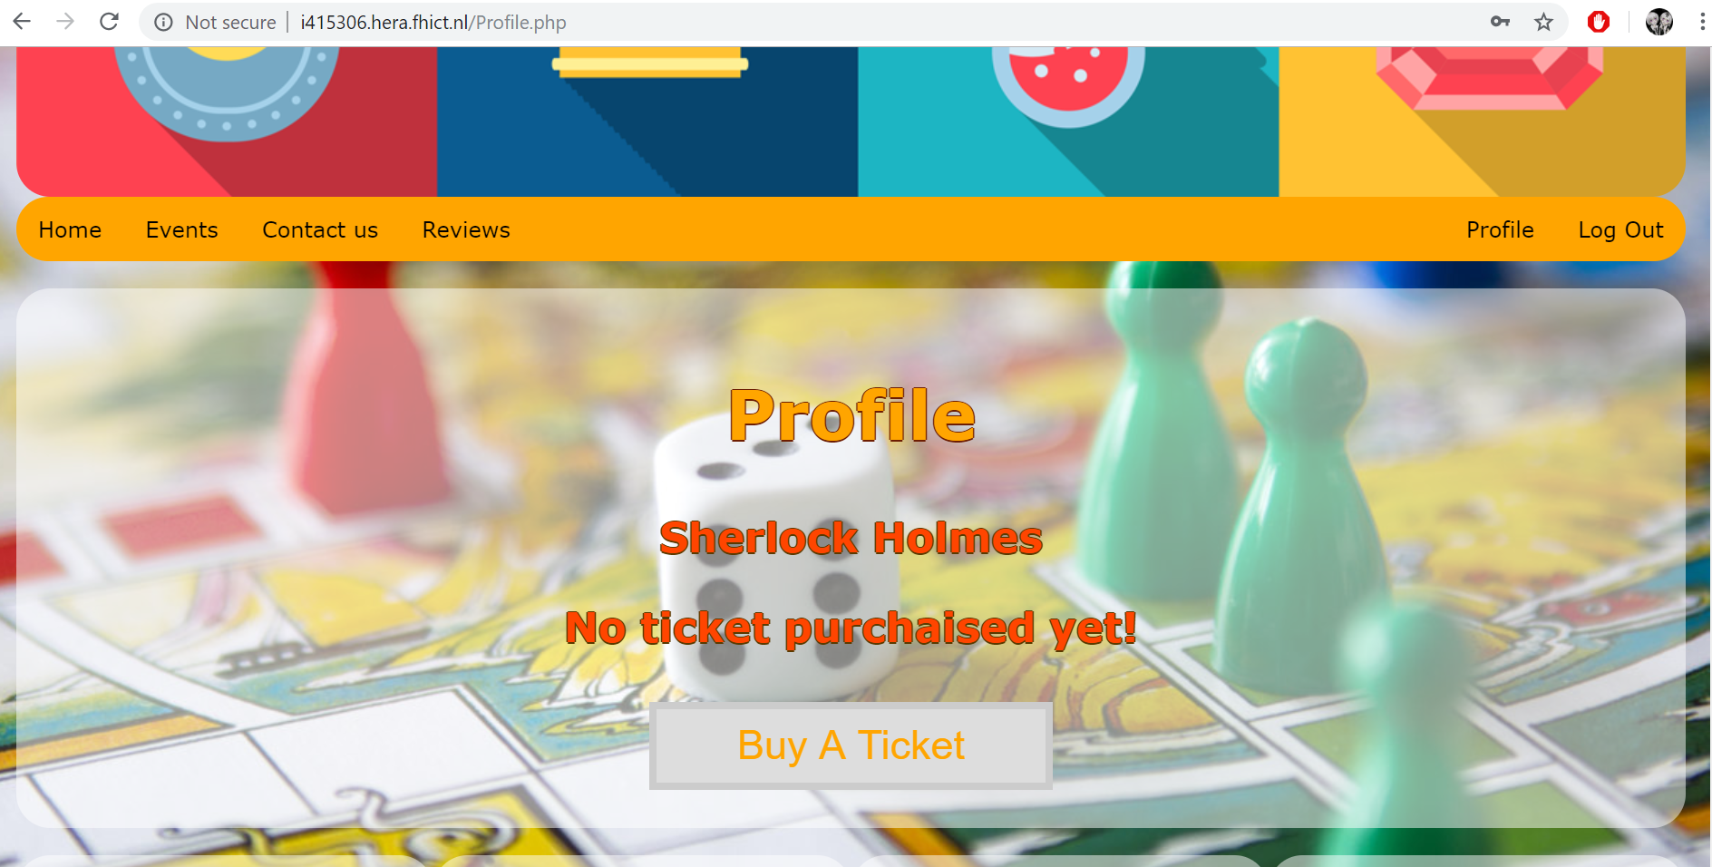

# Buy a ticket

To buy a ticket you need to be logged in. Go to your profile (if you’re logged in – you will see “Profile” link in the right side of the menu bar). You need to click “Buy a Ticket” button.  
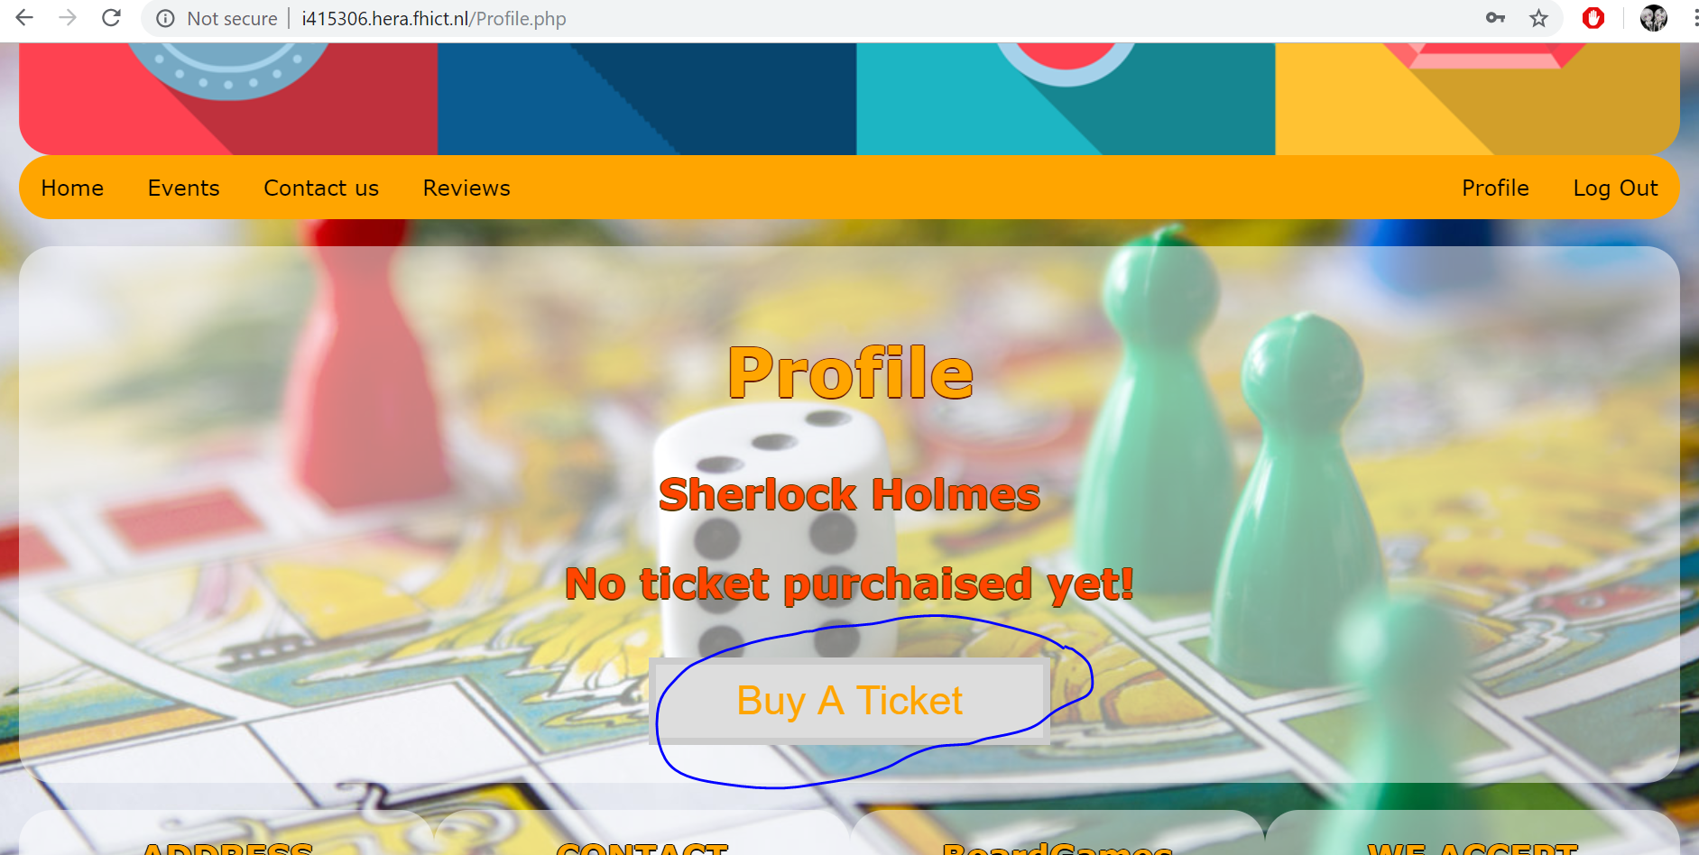

This button is also available on the Home page and will redirect you on the same “Ticket purchase” page, if you click it while being logged in. If you already have a ticket – the button will not be visible.

After clicking it you will be redirected to a page where you can select merchandise that you want to add you your ticket purchase. Circled with red are the ticks for selecting the merch you want, circled with blue – the purchase confirmation button. You need to click it after selecting the desired merch  
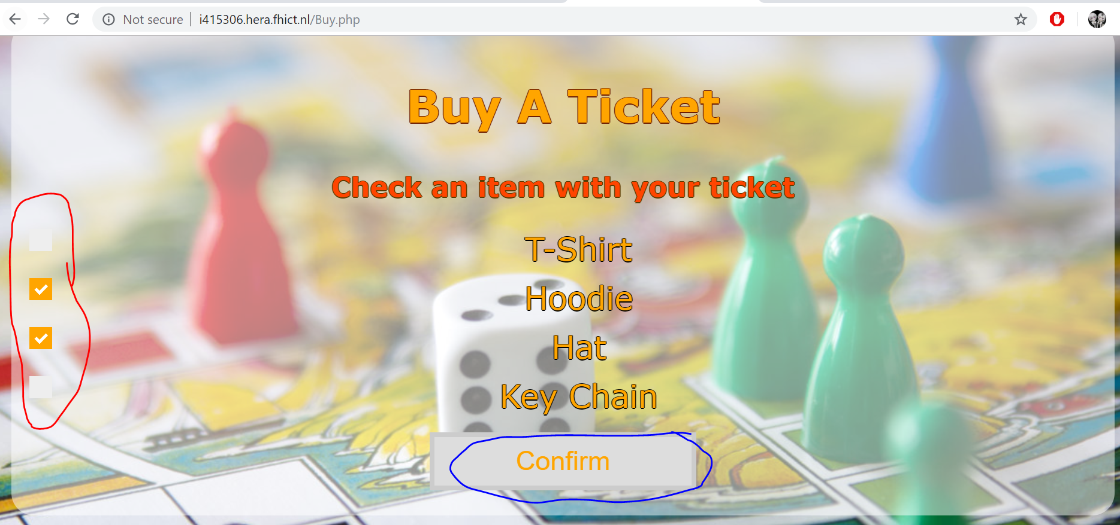

After this operation you will be redirected to your profile page. Information about your merch will be stored, but you are not able to see it. You can see your balance and ticket number in your profile after a ticket purchase. You can also top up your balance or reserve a camping spot.  
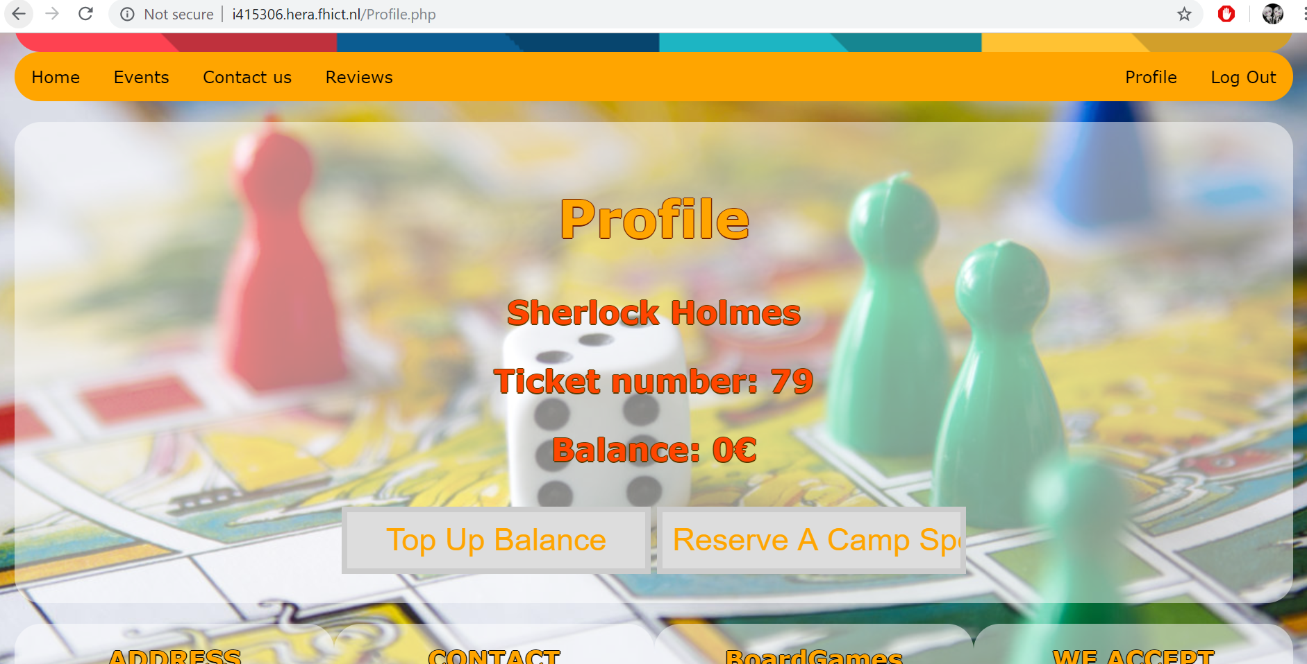

After ticket purchase, a QR code of your ticket will be sent to the email address you provided. Make sure you check your spam folder.  
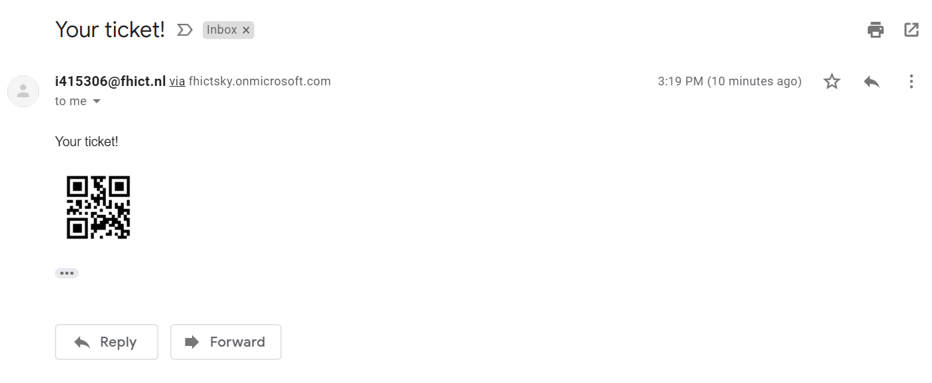

# Top up balance

To top up your balance you need to be logged in and have a ticket purchased. In your profile you need to press on “Top Up Balance” button.

On top up balance page you can select amount you want to add to your account. This amount with be withdrawn (virtually) from the IBAN you provided during registration. Click “Accept” button to confirm the operation.   
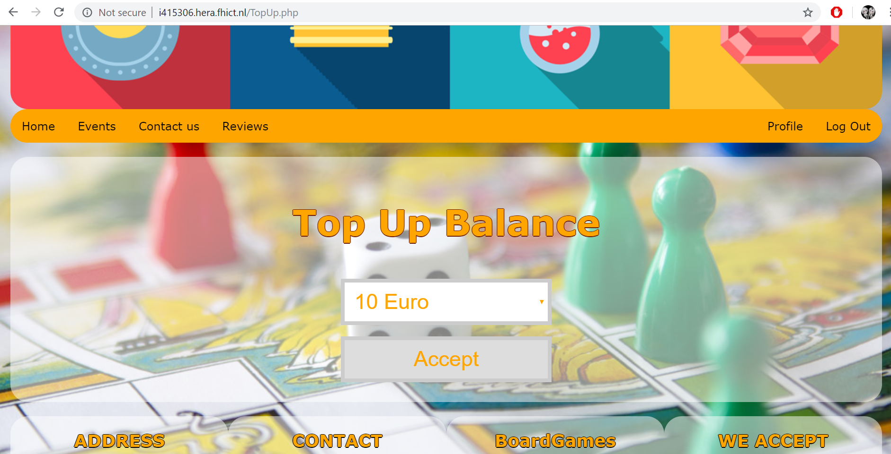

You will be redirected to Profile page where you can see your balance topped up with amount you selected in the previous step.  
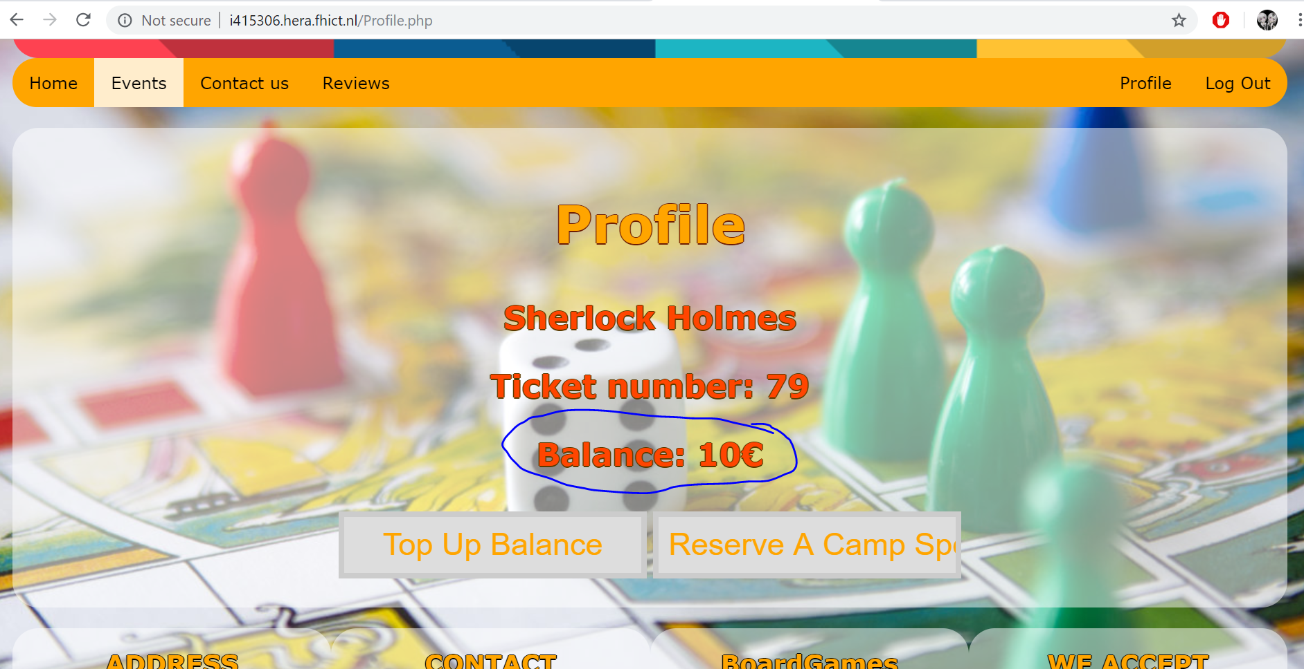

# Reserve camping

To reserve a camping spot, you need to be logged in and have a ticket purchased. In your profile you need to press on “Reserve a Camp Spot” button. (A front-end bug with this button will be fixed before final version is released).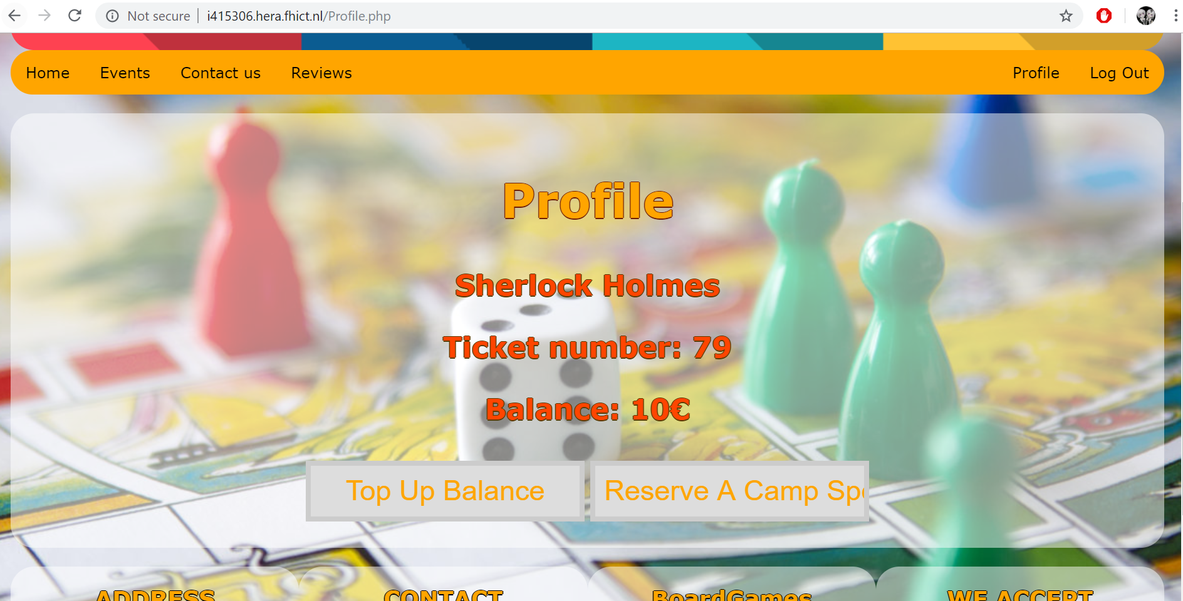

On camp spot reservation page, you can choose a camp spot and for how many people you want to reserve this spot. It is possible to choose to pay for your reservation right away or to pay for it later, on the festival. For paying now you need to select “Pay now” option. After submitting all the necessary data – click “Accept” button. It will only be possible to reserve a camp spot if there are enough unreserved spaces in this camp spot. If you pressed “Pay now” button – you need to have sufficient for this reservation amount on your account’s balance, otherwise you won’t be able to reserve a camp spot.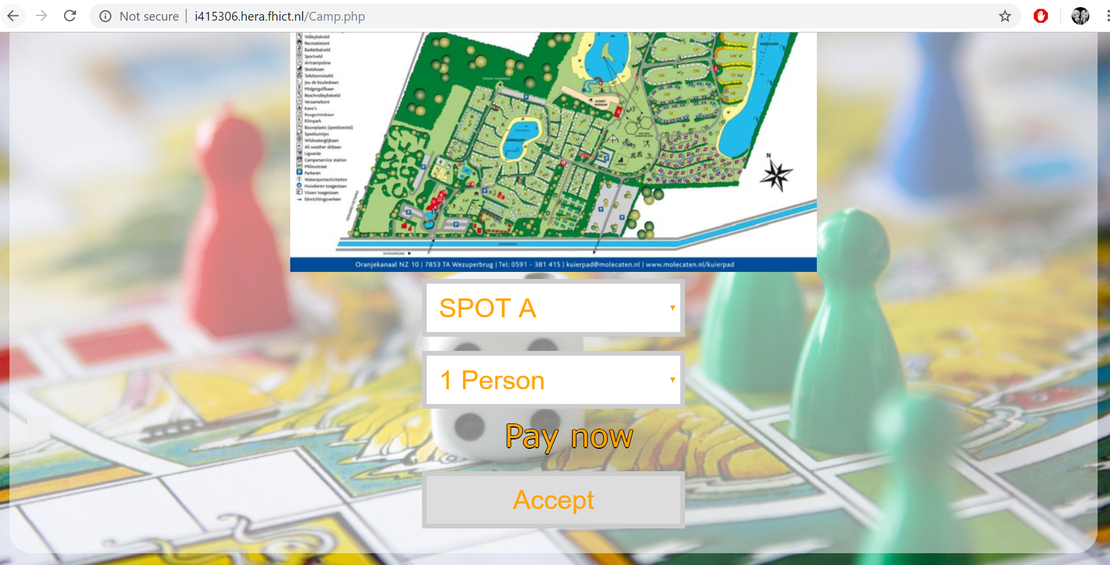

If your reservation was successful, you will be redirected to profile page.

# Leave a review

To leave a review you need to go to “reviews” page. It can be done by pressing “Review” button in menu bar. 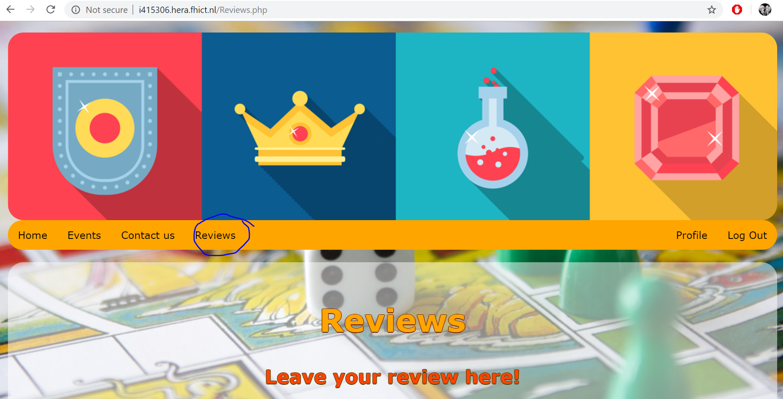 To leave a review you need to be logged in, have a ticket purchased and not have an already left review.

If all the three mentioned requirements are fullfilled, you will see a review leaving form.  
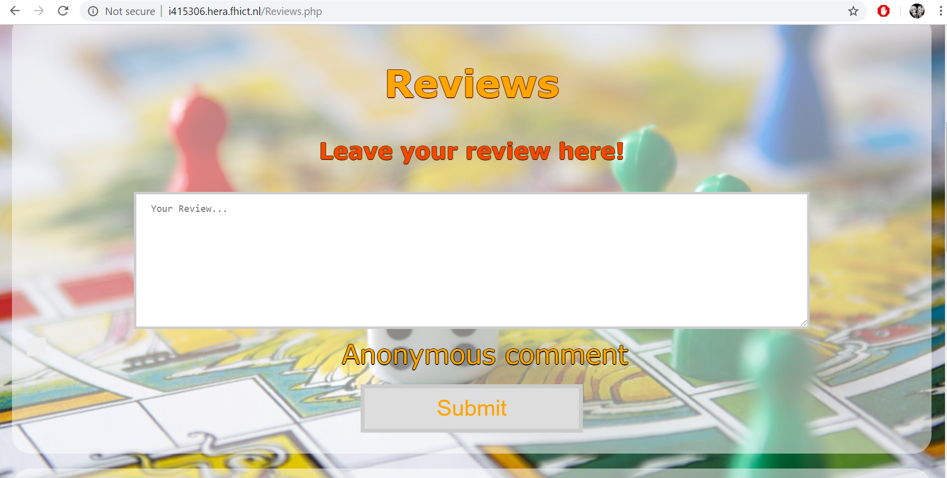

Here you can leave your review. Under this form you can see reviews that are already left. You can post a review under your own name that is provided in your account or make it anonymous. You can only leave a review once. After submitting your review, it will be posted. You will no longer be able to leave a review, but your review will be seen among other reviews on this page.  
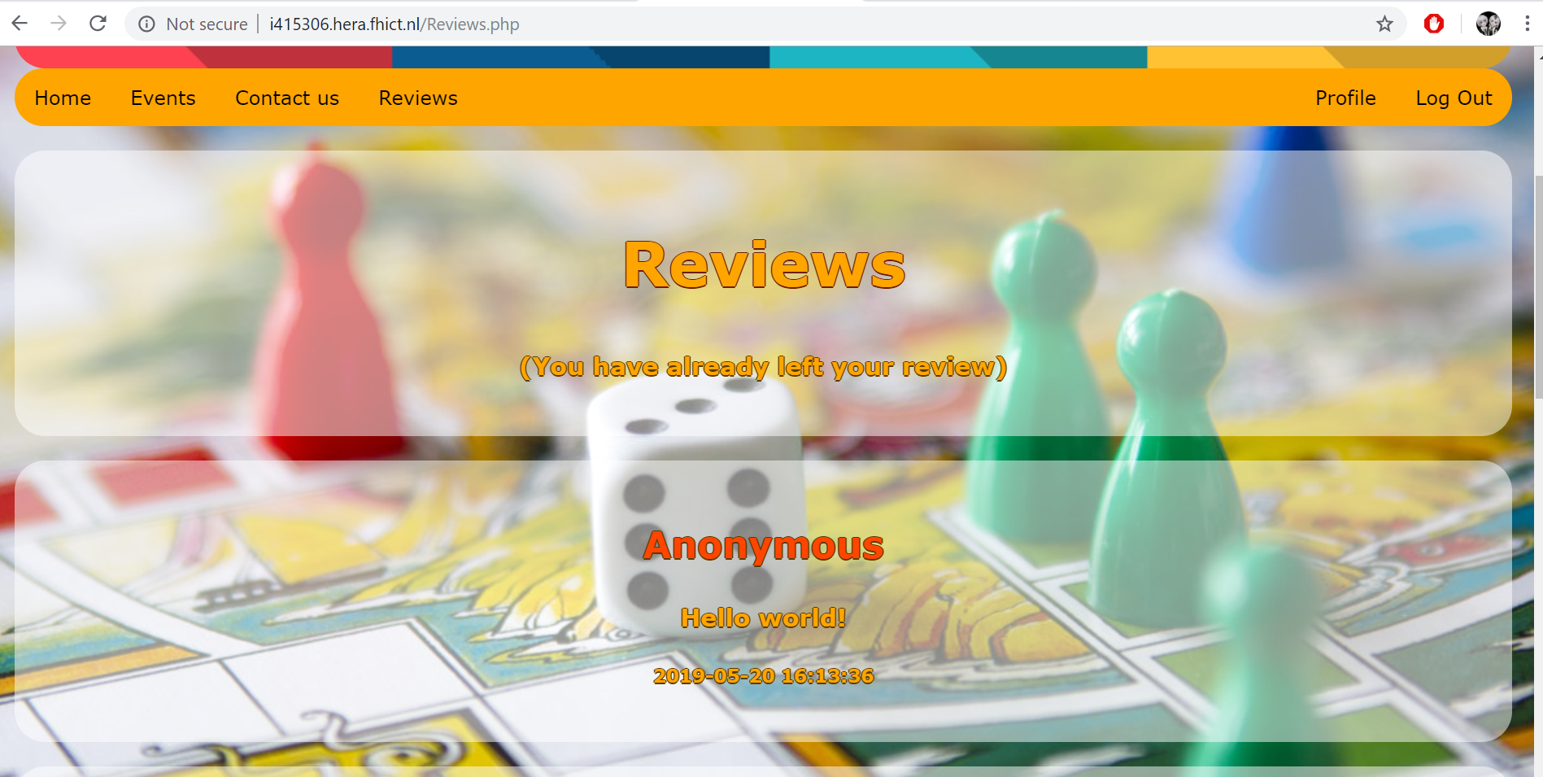

(Your review).  
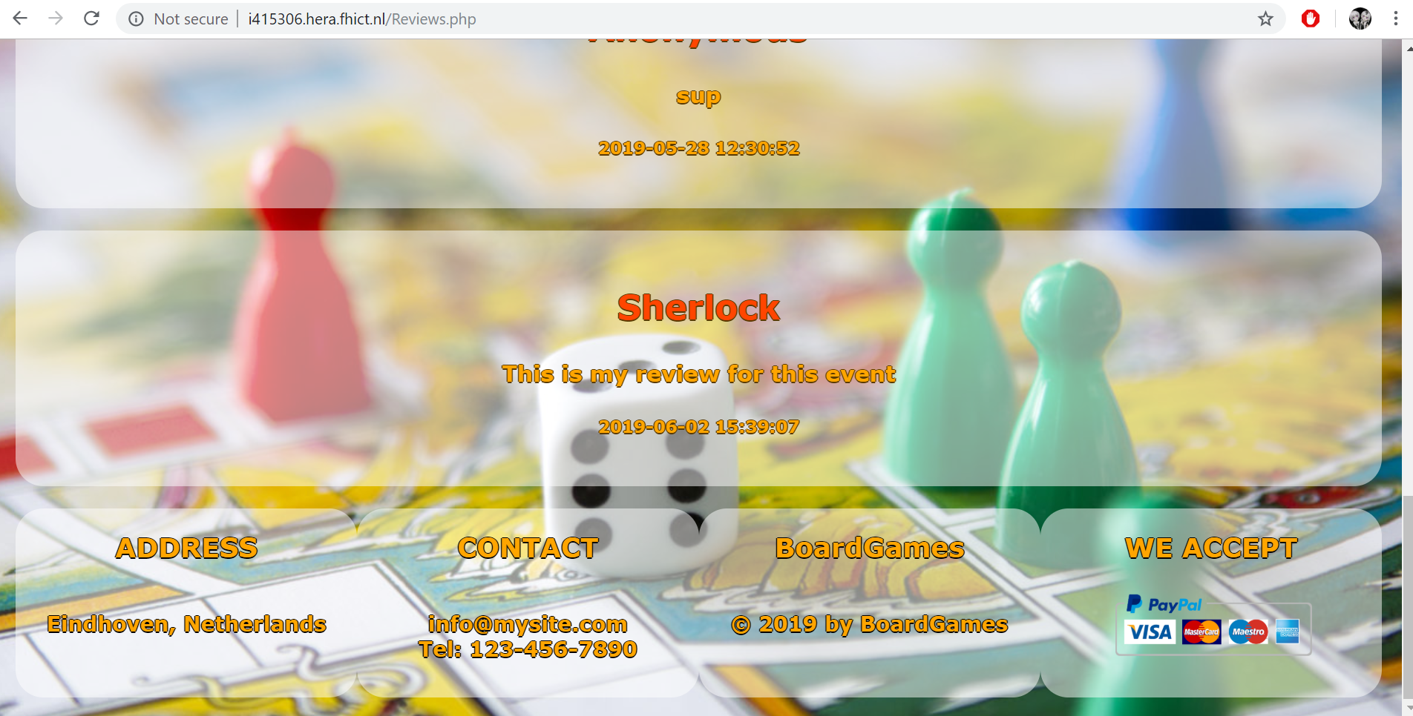

# Contact Us

It is possible to contact us. For that you need to go to “Contact Us” link in menu bar. Now there are our details, but it can be changed to event’s organizers’ details if necessary.

To send a message you need to fill the form and submit it by clicking “Submit” button.  
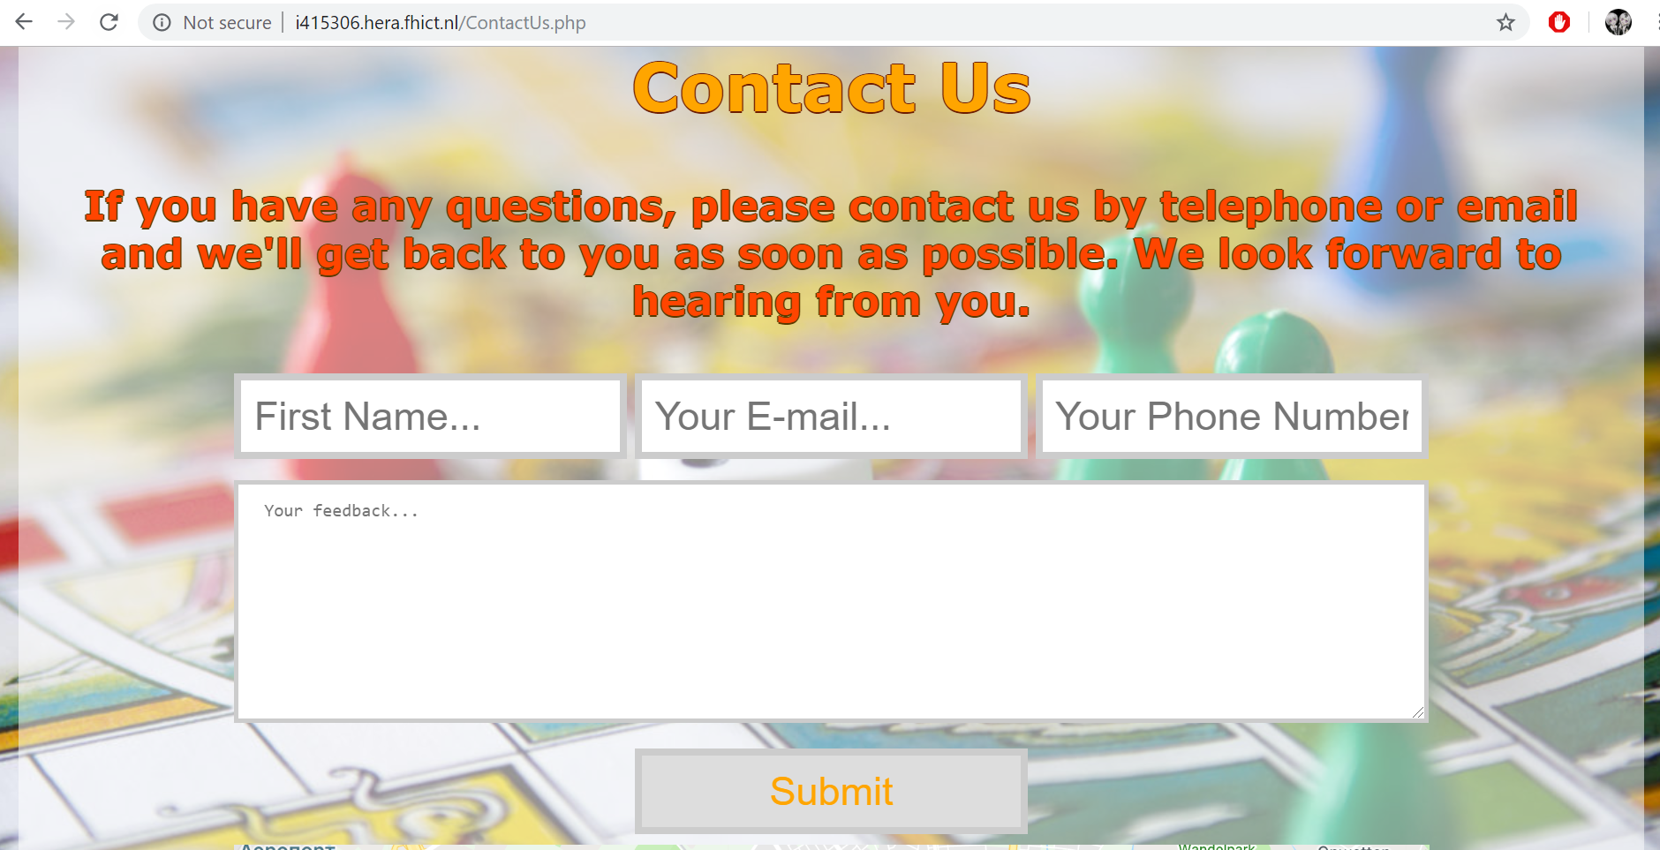

# Apps

## Login window

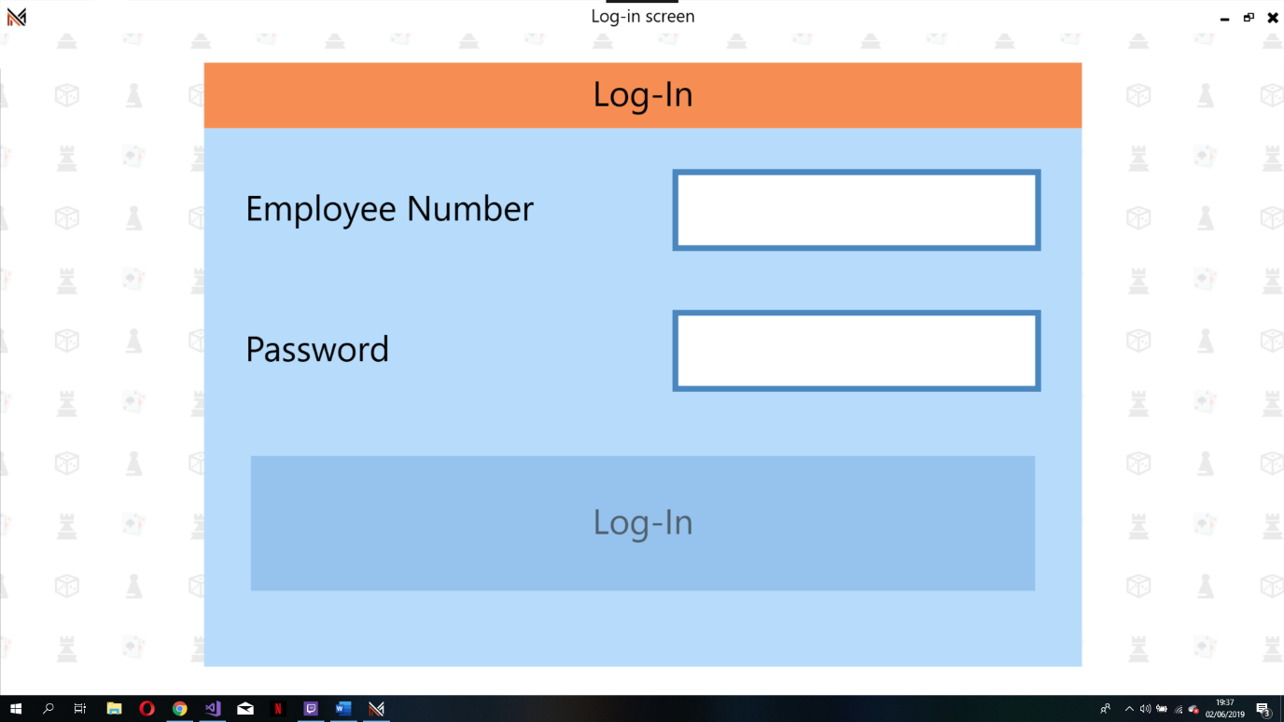

## Apps window (provide access to employees apps)

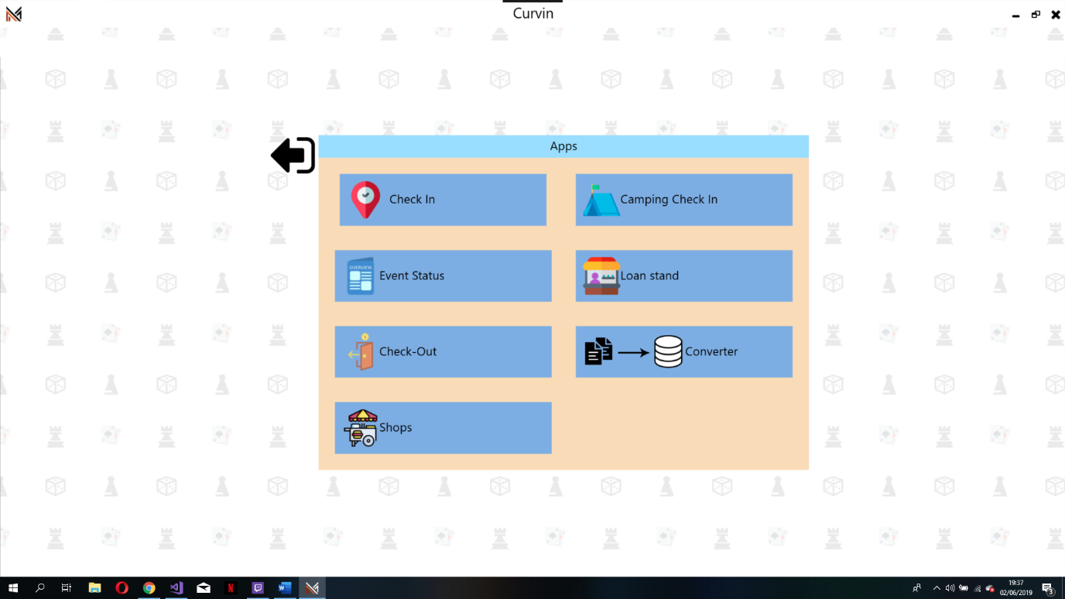

## Check in window

User can either scan a ticket qr code or sell a ticket to a visitor

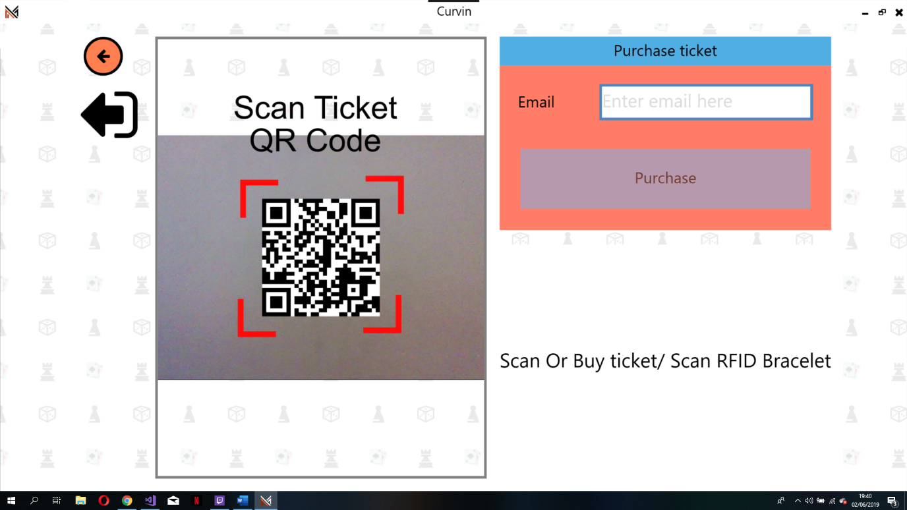

After scanning qr code

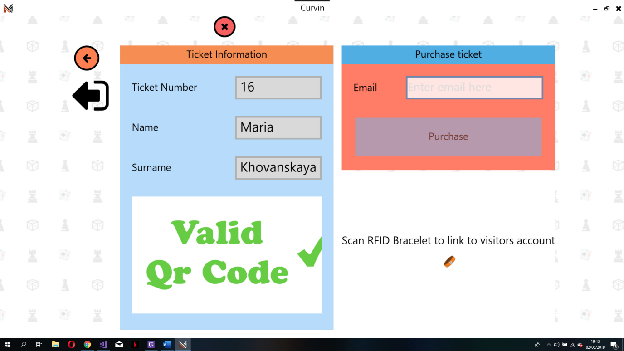

## Camping window

User must scan visitors rfid braclet

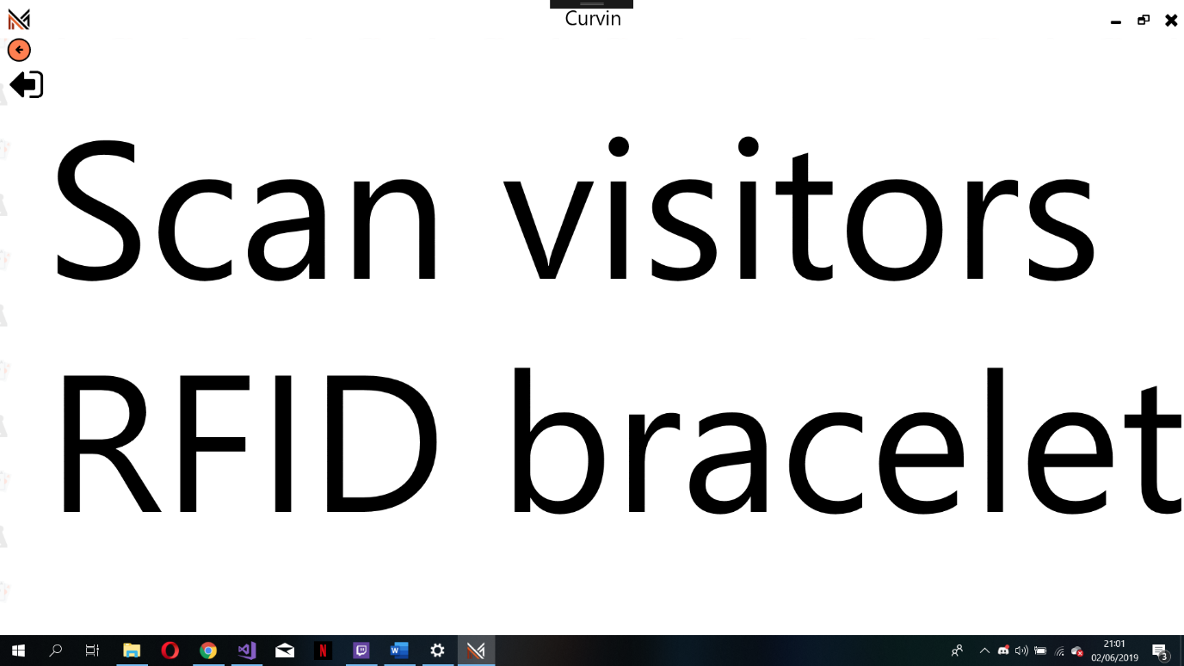

If visitor must pay for camping spot

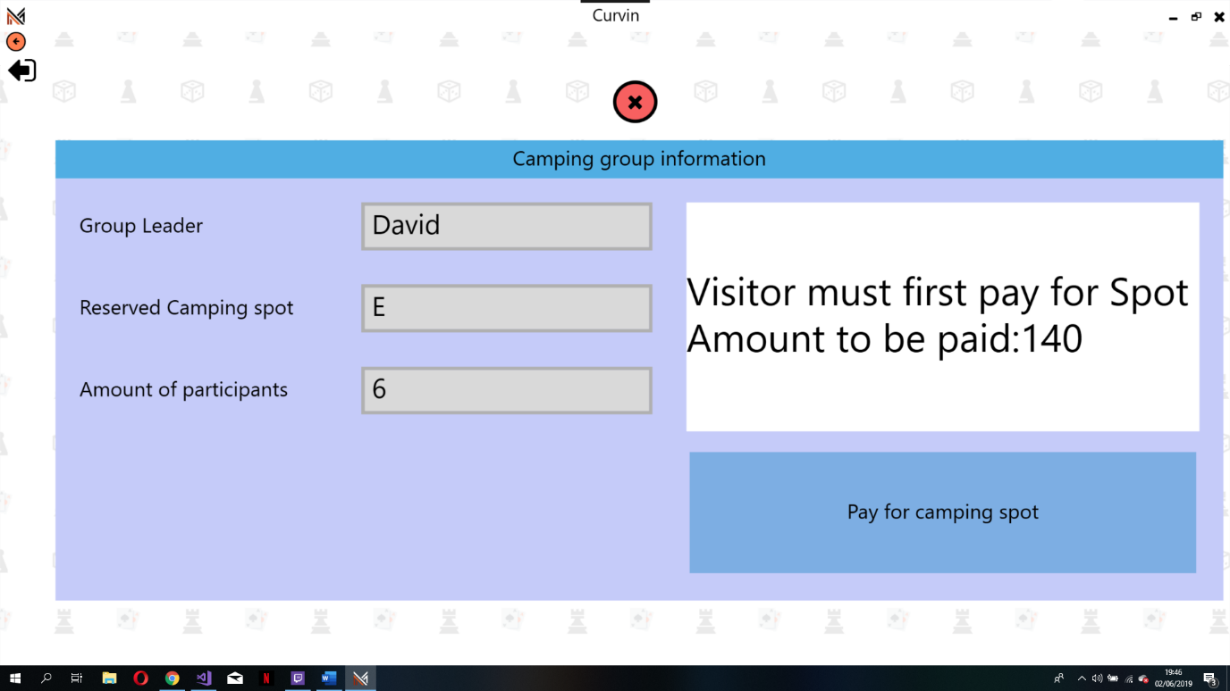

If visitor already paid

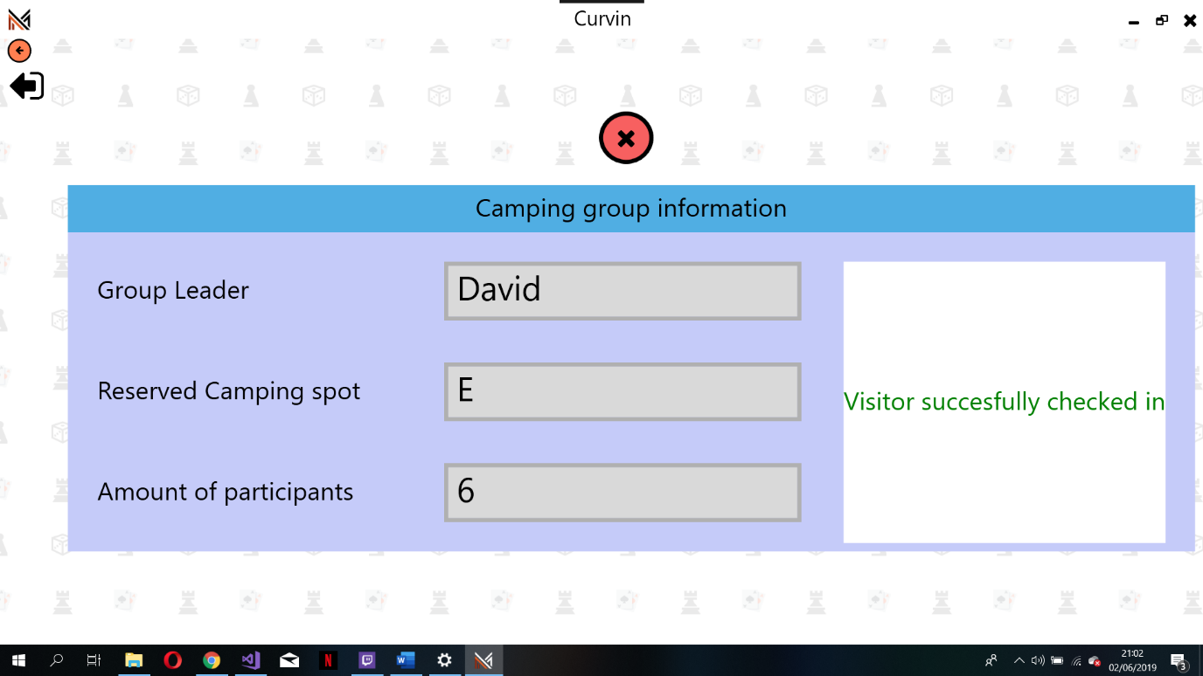

## Status overview window

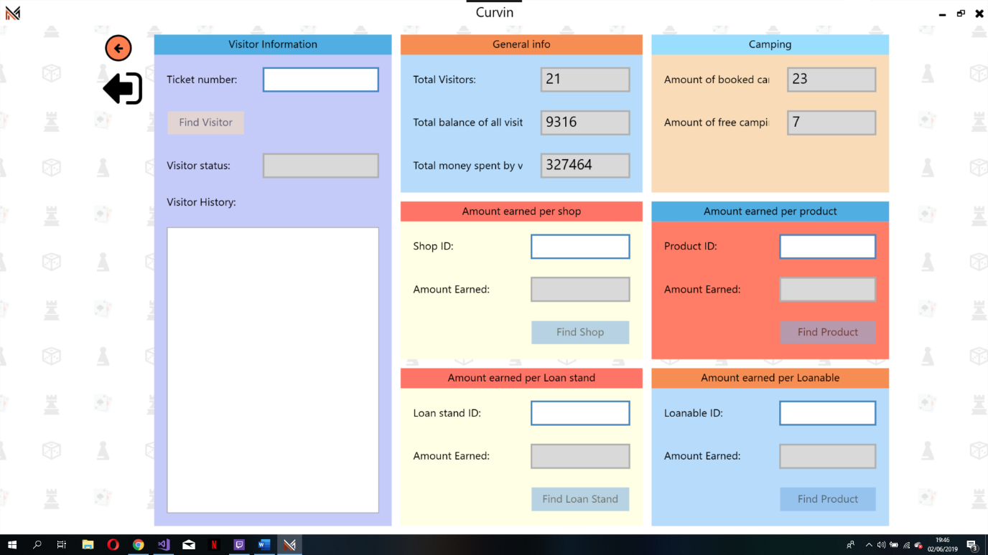

## LoanStand window

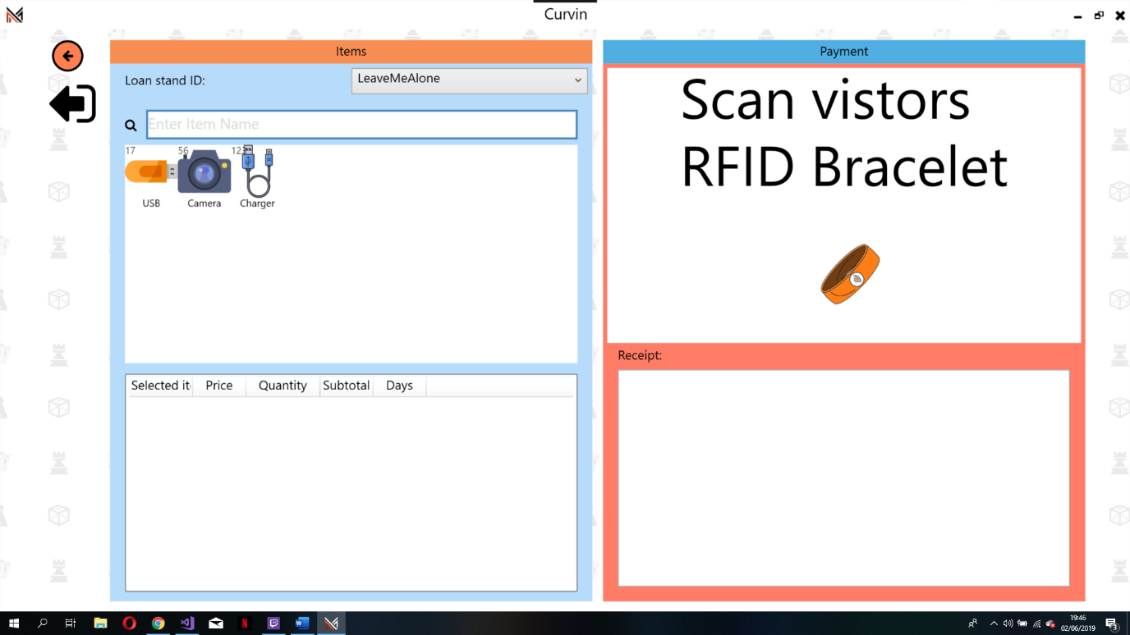

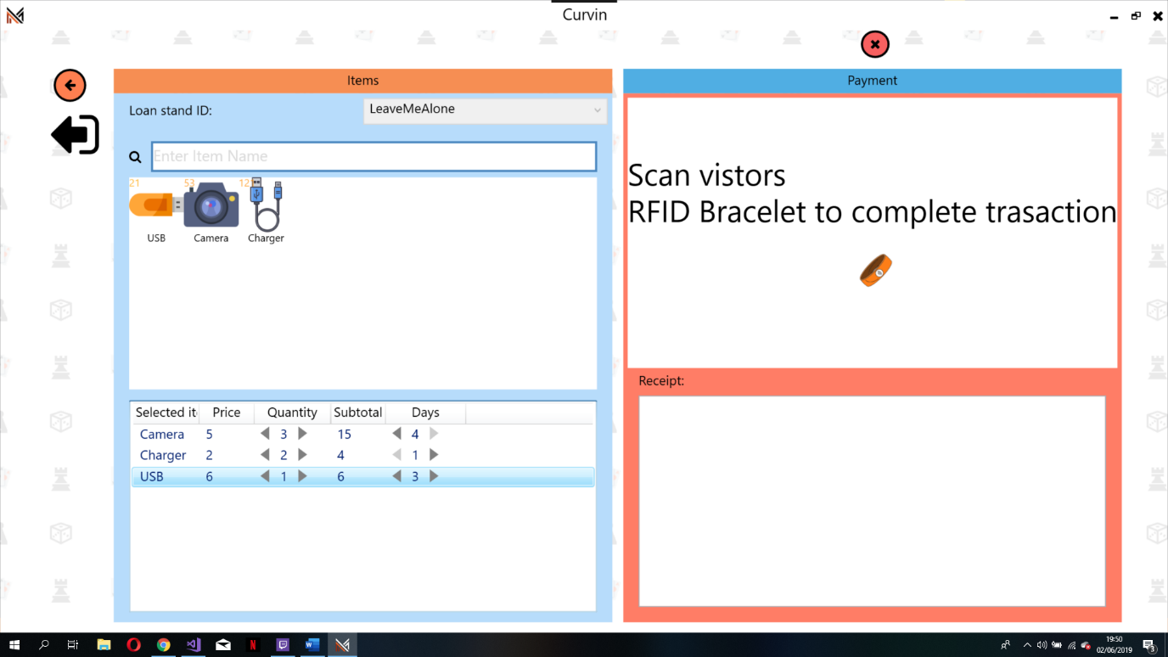

## Checkout window

After scanning the visitors rfid bracelet the user sees this

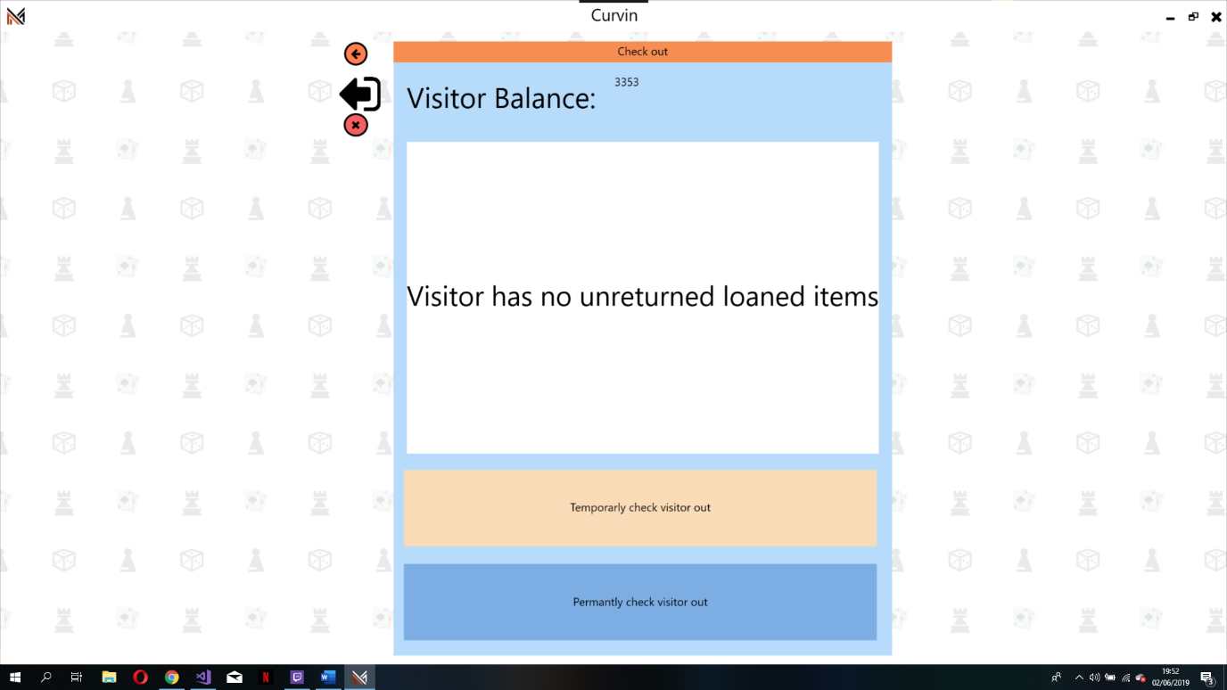

## Converter window(ATM)

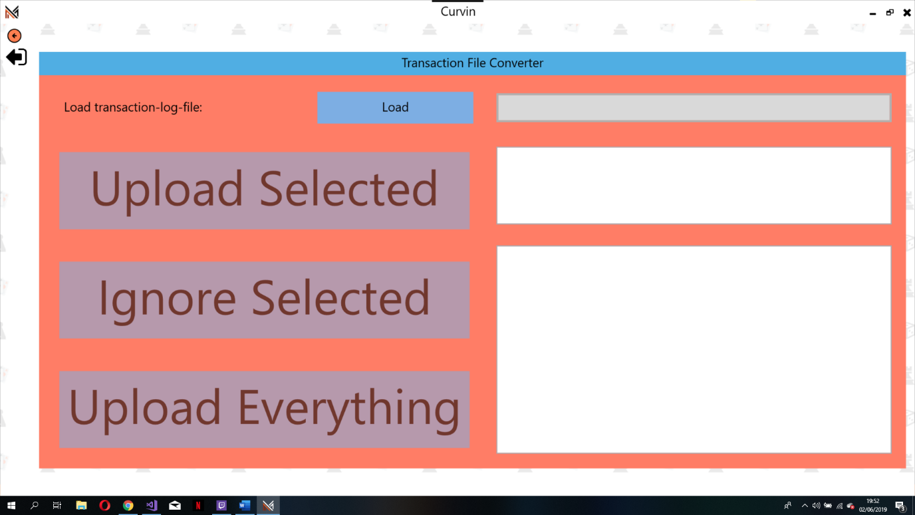

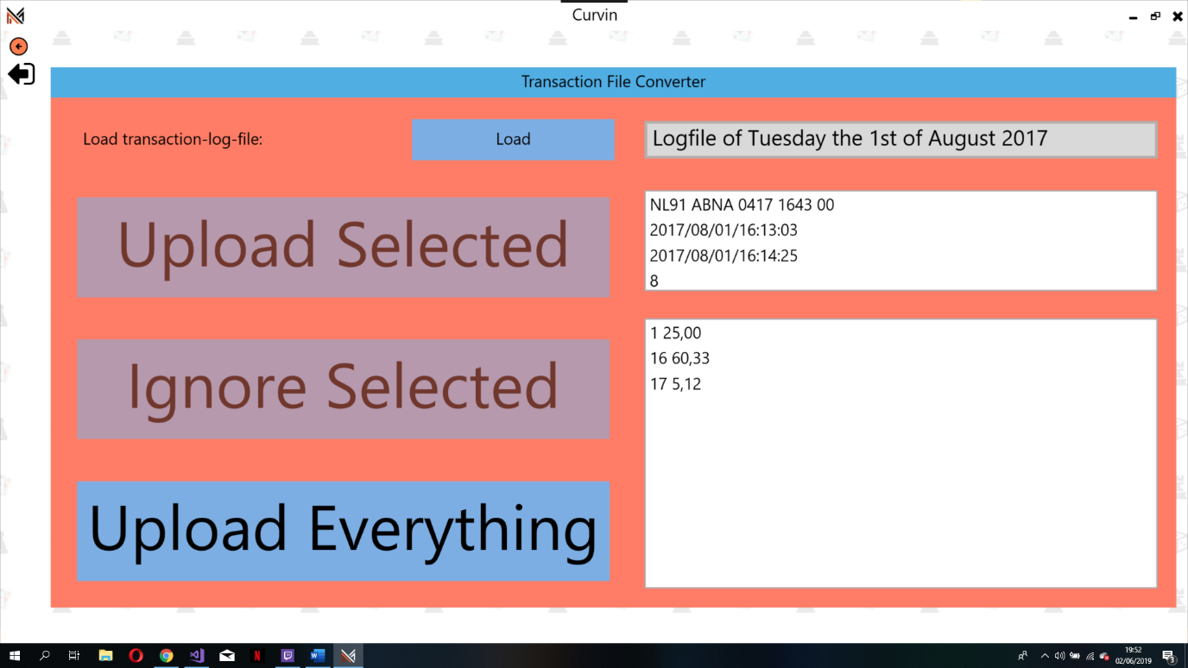

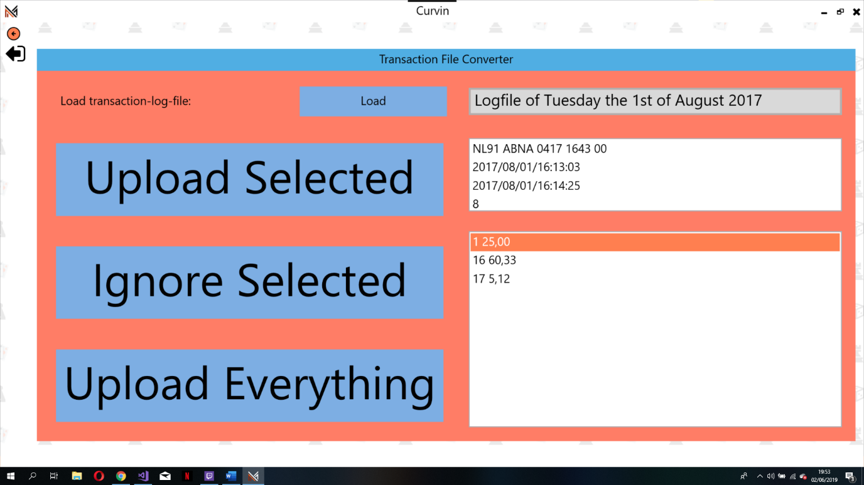

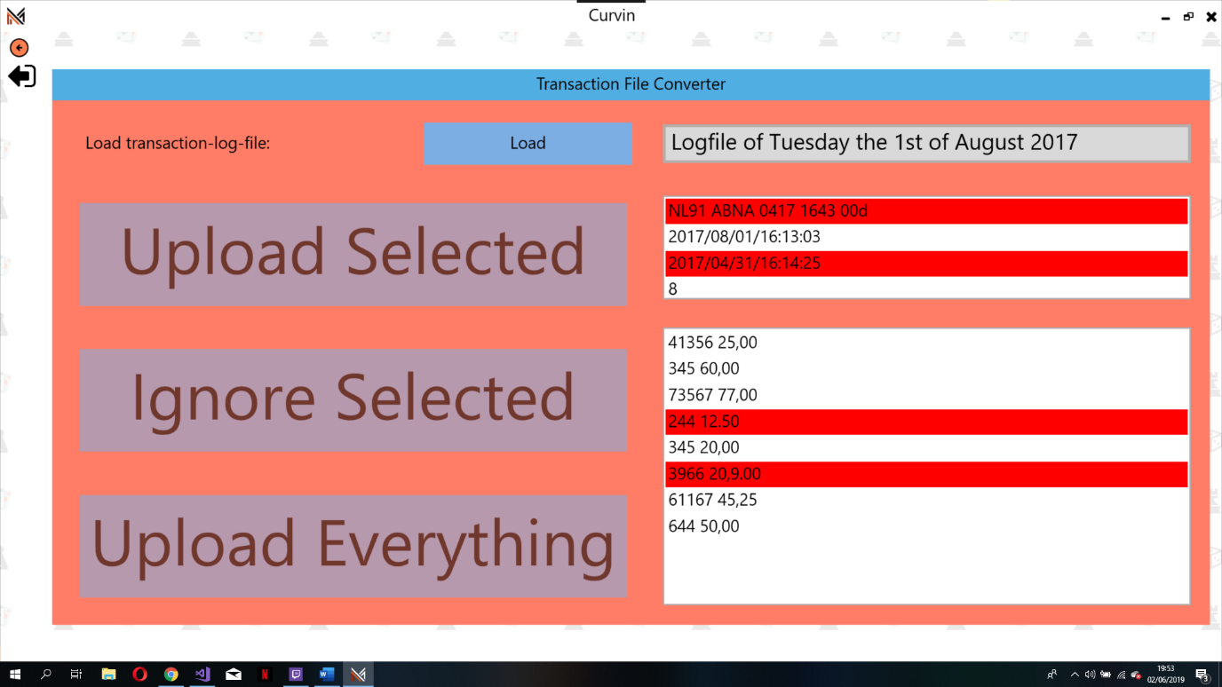The red bars are lines in the log file that is not in the correct format. If something is wrong with on of the first four lines than the user cannot upload any lines from this file. If the format of a line after the first 4 lines is incorrect then the user can still upload but cannot upload any of the incorrect formatted lines.

## Shop window

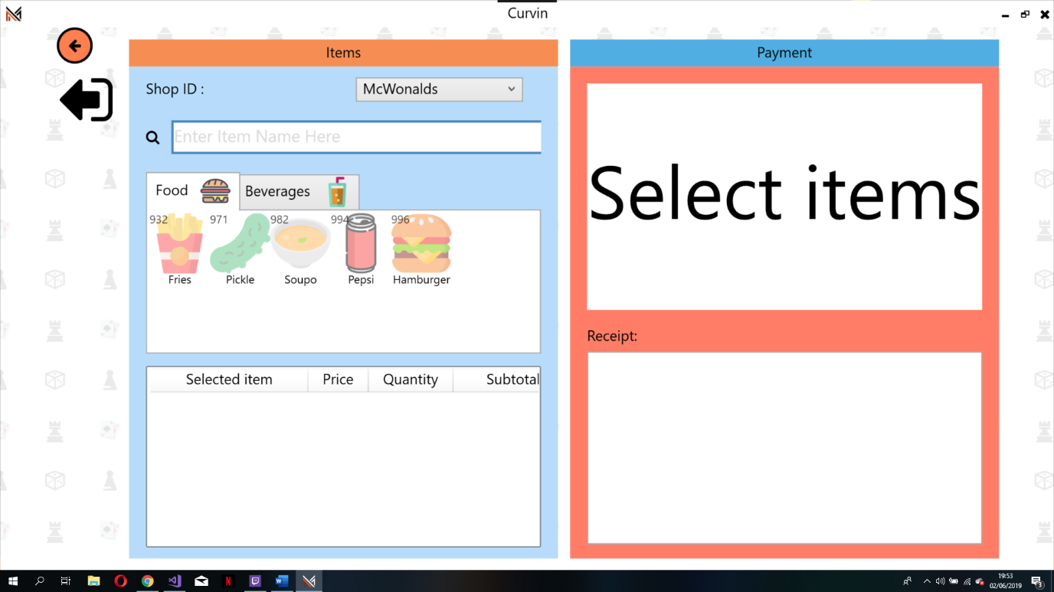

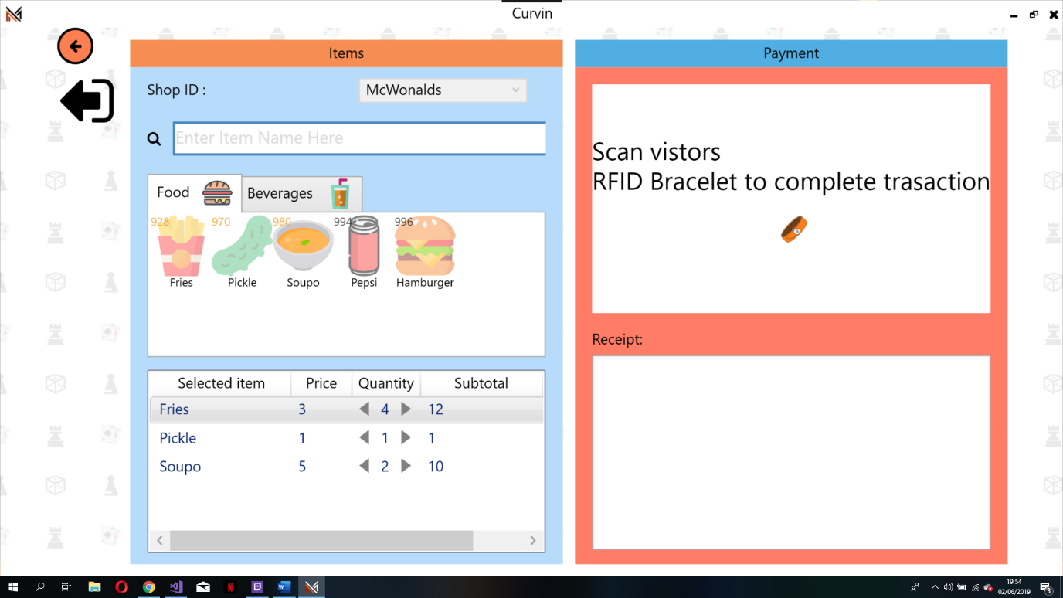

## Admin window

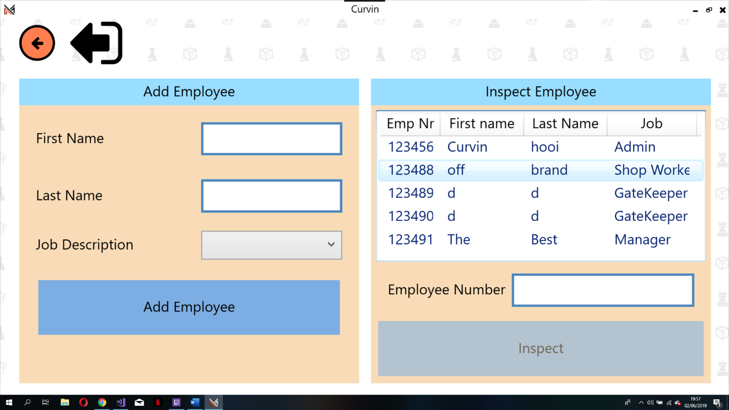

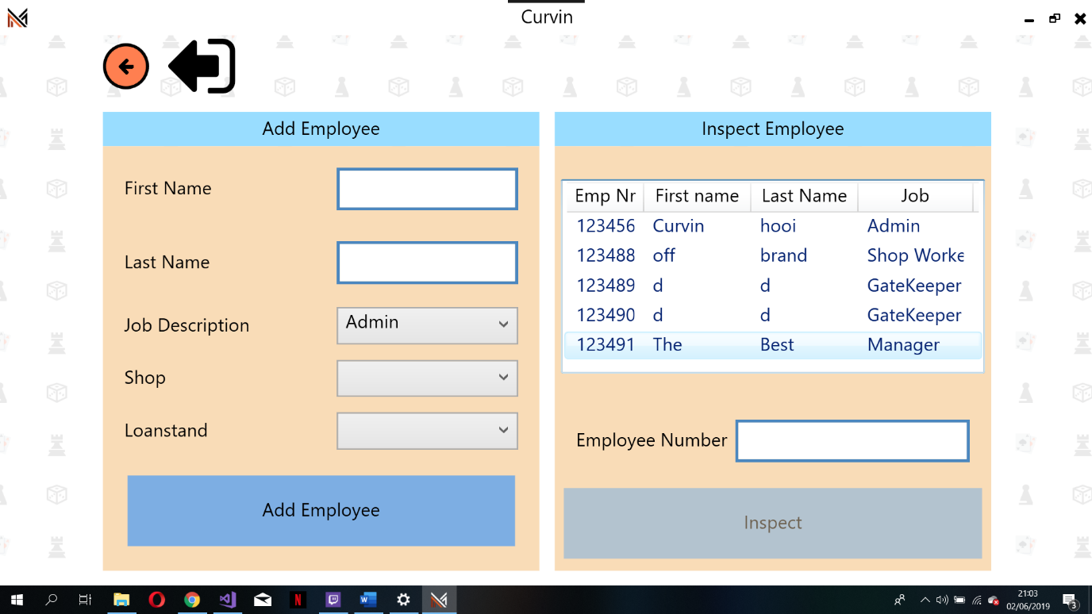The user can search for a employee by typing any of the following in the text box Their job, first name, last name and employee number. User only sees the shop and loan stand option when the selected job description has either a shop or loan stand. So if a loan stand worker only has access to the loan stand app than the user will only see the loan stand option.

